ANNUAL EXAM 2024-25

Class - IX [Mathematics] Date: MM: 80

General Instructions:
1. This Question paper has 5 sections A-E.
2. Section - A has 20 MCQs carrying 1 mark each.
3. Section - B has 5 questions carrying 2 marks each.
4. Section - C has 6 questions carrying 3 marks each.
5. Section – D has 4 questions carrying 5 marks each.
6. Section – E has 3 case based integrated units of assessment (4 marks each) with subparts of the values of 1, 1 and 2 marks each respectively.
7. All questions are compulsory . However, an internal choice in 2Qs of 5 marks, 2Qs of 3 marks and 2Qs of 2 marks has been provided.
8. Draw neat figures wherever required. Take π = 22/7 wherever required, if not stated.

Section A
- Which of the following is a rational number?
a)1+$\sqrt{3}$ b)π c)2$\sqrt{3}$ d)$\frac{\sqrt{4}}{\sqrt{9}}$
2. Zeroes of the polynomial p(x) = 2x² + 5x – 3 are
a) $\frac{1}{2}$ , 3 b) $\frac{1}{2}$ , -3 c) $-\frac{1}{2}$ , -3 d) - $\frac{1}{2}$ , 1
3. The point whose ordinate is 3 and which lies on the y-axis is:
a) (3,0) b) (0,3) c) (3,3) d) (1,3)
4. The point (-a, a) will always lie on the line
a) x = a b)y = a c )x=y d) x+y=0
5.Euclid’s which axiom illustrates the statement that when x + y = 15, then x + y + z = 15 + z?
a)Things which are equal to same thing are equal to one another
b) If equals are added to equals, the wholes are equal.
c) If equals are subtracted from equals, the remainders are equal.
d) The whole is greater than the part.
6. In ∆ABC, BC=AB, and 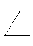B=80º. Then A=?
a)50º b)40º c)100º d)80º
7. The angles of the quadrilateral are in the ratio 3:4:5:6. The smallest of these angles is:
a)45º b)60º c)36º d)48º
8.In the given fig., BOC is a diameter of the circle and AB=AC. Then ABC=?
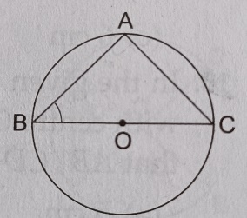
a) 30º b)45º c)60º d)90º
9. The area of the equilateral triangle is 36$\sqrt{3}$ cm². Its perimeter is
a)36cm b)12$\sqrt{3}$cm c)24cm d)30cm

10. The height of a cone of diameter 10cm and slant height 13cm is:
a) $√69$ cm b) 13 cm c) 12 cm d) $√194$ cm

11.The class mark of 90 – 120 is
a) 90 b) 105 c) 115 d) 120
12. The measure of an angle which is twice its complement is
a) 30° b) 45° c) 60° d) 90°
13. If a+b+c=0 then (a³ +b³ +c³) is
a)0 b) abc c) 2abc d) 3abc
14. If (3,2) lies on kx + y = 8, then the value of k is
a) 2 b) 3 c) -2 d) -3
15. In the given figure, AOB is a straight line. If AOC=(3x+10)º and BOC=(4x-26)º, then BOC=?
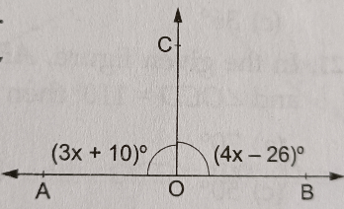
a)96º b)86º c)76º d)106º
16. The number of dimensions, a point has
a) 0 b) 1 c) 2 d) 3
17.In a cone , if the radius is halved and the height is doubled then the volume will be:
a) remain the same b) be doubled c) be halved d) become four times
18.$\sqrt{10}×\sqrt{15}$ = ?
a)$\sqrt{25}$ b)$5\sqrt{6}$ c)$6\sqrt{5}$ d)none of these
19. Assertion: ABCD is a quadrilateral in which P, Q,R and S are the midpoints of AB, BC CD and DA respectively. Then, PQRS is a parallelogram.
Reason: The line segment joining the midpoints of any two sides of a triangle is parallel to the third side and equal to half of it.
- Both Assertion (A) and Reason(R) are true and Reason (R) is the correct explanation of Assertion(A).
- Both Assertion (A) and Reason(R) are true and Reason (R) is not the correct explanation of Assertion(A).
- Assertion(A) is true but Reason(R) is false.
- Assertion(A) is false but Reason(R) is true.
20. Assertion: If ∆ABC $≅$ ∆RPQ, then BC = QR.
Reason: Corresponding parts of two congruent triangles are equal.
- Both Assertion (A) and Reason(R) are true and Reason (R) is the correct explanation of Assertion(A).
- Both Assertion (A) and Reason(R) are true and Reason (R) is not the correct explanation of Assertion(A).
- Assertion(A) is true but Reason(R) is false.
- Assertion(A) is false but Reason(R) is true.

Section B (2X5=10)
21. Find the value of a for which (x-4) is a factor of (2x³ - 3x² - 18x + a)
22. Find two solutions of the linear equation 4x – 3y -12 = 0.
23. If a point C lies between two points A and B such that AC = BC, then prove that AC = $\frac{1}{2}$ AB. Explain by drawing the figure.

24. In the figure, lines PQ and RS intersect each other at point O. If POR : ROQ = 5:7. Find all the angles.
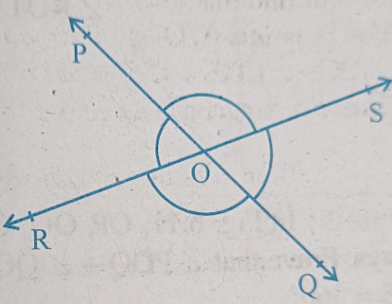

OR
In the fig., if x + y = w + z, then prove that AOB is a line.
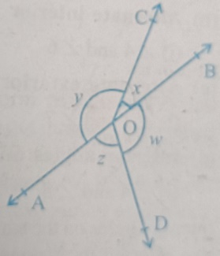

25. A conical tent is 10m high and the radius of its base is 24m. Find the cost of the canvas required to make the tent, if the cost of 1m² canvas is Rs.70.
OR
The radius of a spherical balloon increases from 7cm to 14cm as air is being pumped into it. Find the ratio of surface areas of the balloon in the two cases.

Section C (3X6=18)
26.The three vertices of a rectangle ABCD are A(2,2), B(-3,2) and C(-3,5). Plot these points on a graph paper and find the coordinates of D. Also, find the area of rectangle ABCD.
27. Express $4.\overline{352}$ in the form $\frac{p}{q}$ , where p and q are integers and q ≠ 0.

OR

Evaluate : ${\left(\frac{81}{16}\right)}^{\frac{-3}{4}}$ $\left[{\left(\frac{25}{9}\right)}^{\frac{-3}{2}} ÷{\left(\frac{5}{2}\right)}^{-3}\right]$
28. Factorise x² + 5$√3$ x + 12
29. Find the area of the triangle whose perimeter is 180cm and two of whose sides are 80 cm and 18 cm. Also, calculate the altitude of this triangle corresponding to its shortest side.
30. ABC is a triangle in which altitudes BE and CF to sides AC and AB are equal. Show that
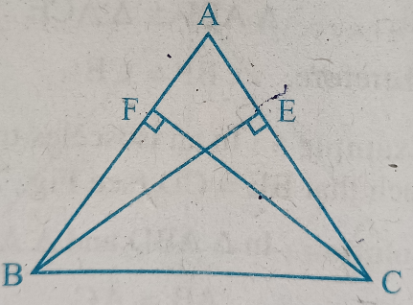
(i) ∆ABE $≅$ ∆ACF
(ii) AB=AC, i.e, ABC is an isosceles triangle.
OR

Line l is the bisector of an angle A and B is any point on l. BP and BQ are perpendiculars from B to the arms of A. Show that :

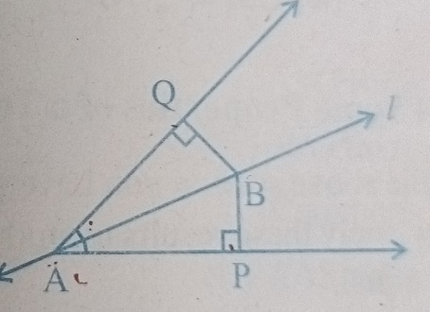

- ∆APB $≅$ ∆ AQB
- BP = BQ or B is equidistant from the arms of A.

31. If the diagonals of a cyclic quadrilateral are diameters of the circle through the vertices of the quadrilateral, prove that it is a rectangle.

Section D (5X4=20)
32. If a and b are rational numbers and $\frac{4+3\sqrt{5}}{4-3\sqrt{5}}$ = a + b$\sqrt{5},$ find the values of a and b.

32. (i) Verify: x³ + y³ = (x+y) (x² -xy +y²)
(ii) Give possible expressions for the length and breadth of the following rectangle, the area of which is given as:
Area: 25a² - 35a + 12.
33. Twenty seven solid iron spheres each of radius r and surface area S are melted to form a sphere with surface area S’. Find the
(i) radius r’ of the new sphere (ii) ratio of S and S’
OR

A hemispherical dome of a building needs to be painted. If the circumference of the base of the dome is 17.6m, find the cost of painting it, given the cost of painting is Rs.5 per 100cm².

35. 100 surnames were randomly picked up from a local telephone directory and a frequency distribution of the number of letters in the English alphabet in the surnames was found as follows:

Number of letters | Number of surnames
1 – 4 | 6
4 – 6 | 30
6 – 8 | 44
8 – 12 | 16
12 – 20 | 4

- Draw a histogram to depict the given information.
- Write the class interval in which maximum number of surnames lie.

OR
The following table gives the distribution of students of two sections according to the marks obtained by them:
Section A |  | Section B
Marks | Frequency | Marks |  | Frequency
0 - 10 | 3 | 0 - 10 | 5
10 - 20 | 9 | 10 - 20 | 19
20 – 30 | 17 | 20 – 30 | 15
30 – 40 | 12 | 30 – 40 | 10
40 - 50 | 9 | 40 - 50 | 1

Represent the marks of the students of both the sections on the same graph by two frequency polygons. From the two polygons compare the performance of the two sections.

Section E (Case Study Based Questions)
36. Case Study -1
- A farmer has a circular garden as shown in the picture below. In the garden, there are two mango trees A and B at a distance of AB = 10m. Similarly, has two Ashok trees at the same distance of 10m as shown at C and D.
AB subtends AOB = 120° at the center O. The perpendicular distance of AC from the center is 5m and the radius of the circle is 13m.
Based on this information answer the following questions:
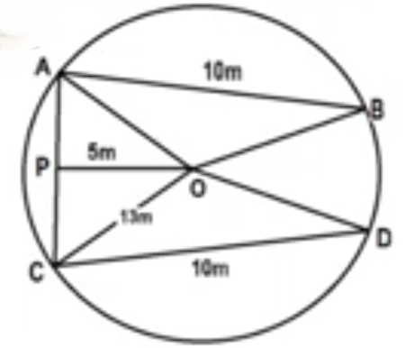

- What is the value of COD? (1)
- What is the value of OAB ? (1)
- What is the distance between mango tree A and Ashok tree C? (2)

37. Case Study-2

In an activity period , class teacher gave students coloured paper in the shape of a quadrilateral. She asks them make a parallelogram from it using paper folding.

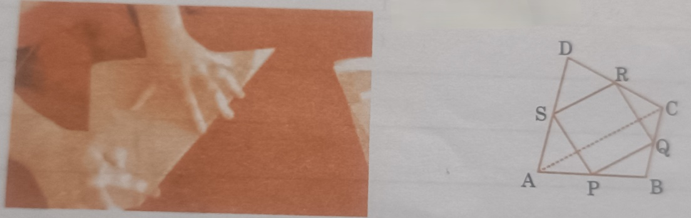
- Show that SR ║ AC and SR = $\frac{1}{2}$ AC (1)
- Prove that PQRS is a parallelogram. (2)
- If one angle of a parallelogram is 108°, find the remaining three angles? (1)

38. Case Study – 3
Teachers and students of class IX of a school had gone to Nandan Kannan for study tour. After visiting different places of Nandan Kannan, lastly, they visited birds sanctuary and deer park. Rohan is the clever boy and keen observer. He put the question to his friends,”How many birds are there in Nandan Kannan?”Rahul’s friend, Nishith gave the the correct answer as follows:
‘Nishith answered that total animals have 1000 eyes and 1400 legs.’
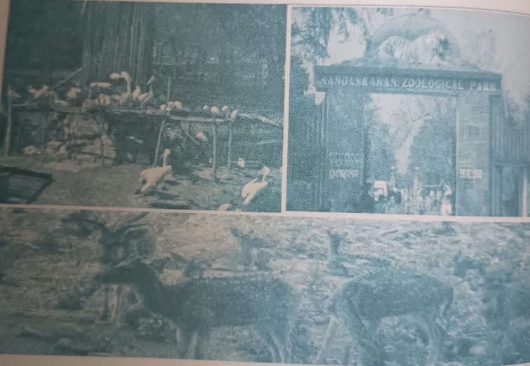
- If x and y be the number of birds and deer respectively, write the linear equation of total number of eyes? (1)
- Write the equation for the total number of legs? (1)
- How many birds are there in the zoo? (2)

